Academic Libraries at the Heart of Sustainable Development: Mapping an Emerging Role
Fatima Kajama ,Hassan El Ouazzani and Hanane El Yousfi
Laboratory Mediation, Information, Knowledge, Society , School of Information Sciences, Morocco- E-mail: fatima.kajama@esi.ac.ma
Laboratory Mediation, Information, Knowledge, Society , School of Information Sciences, Morocco - E-mail: helouazzani@esi.ac.ma
School of Information Sciences, Morocco - E-mail: hel-yousfi@esi.ac.ma

Abstract
The university is a vital institution for the economic, social, and cultural development of nations. The academic library should not be viewed as a mere auxiliary annex or a simple document repository. On the contrary, it is a central component that fully supports the university's academic mission. By organizing information, ensuring equitable access to resources, raising awareness, promoting civic engagement, and supporting scientific research, the academic library serves as a conduit of knowledge that enhances boosts academic performance and fosters innovation.
Academic libraries have untapped potential to support sustainability commitments. However their role in this area remains largely invisible and is rarely integrated into cultural policies.
This paper aims to examine how academic libraries contribute to the implementation of the Sustainable Development Goals through their practices and strategies. It presents a bibliometric mapping of scientific publications from 2015 to 2025 related to “university libraries and sustainable development,” using data extracted from the Scopus database. The objective is to visualize and analyze various bibliographic patterns with VOSviewer software, in order to identify major trends in the field.
The resulting could highlight a body of work that acknowledges the active role of academic libraries in the transition to sustainability such as their support for open science, the development of sustainability-oriented services, and the promotion of eco-responsible practices.
This contribution therefore seeks to reposition academic libraries as full-fledged actors within university sustainability strategies.
Keywords: Academic libraries - Sustainable development - Cartographic approach - Higher education - VOSviewer visualization

- Introduction
In its broadest sense, according to the dictionary of sustainable development, sustainable development encompasses four key dimensions : economic viability, social progress, environmental sustainability, and cultural diversity. Culture is not merely the “icing on the cake” but rather an integral component of the sustainability ecosystem , (adoption in 2005 of the International Convention on Cultural Diversity).
Universities play an essential and diverse role in implementing and achieving the Sustainable Development Goals (SDGs) as defined by the United Nations 2030 Agenda in several ways. Firstly, through teaching and research, providing practical solutions and modeling sustainable practices on university campuses. This enables universities to become models of sustainable practices, showing society how to adopt environmentally friendly behaviors.
In addition, the university promotes inter-disciplinary engagement by encouraging collaboration between various stakeholders, thereby repositioning universities as key players within society (Stephens et al., 2008).
However, in its pursuit for sustainability, the university faces several challenges and obstacles that hinder the adoption of eco-responsible behaviors (Leal Filho et al., 2017). On the one hand, there is inertia in the habits of staff and students who do not adopt waste sorting practices and energy consumption reduction measures. On the other hand, there is the difficulty of integrating sustainable development across all higher education curricula, which restricts student awareness on a large scale.
However, the academic library can help the university overcome these challenges. By offering educational resources and training on sustainable development, it can encourage the adoption of new eco-responsible practices. In addition, by integrating sustainable themes into its programs, the library can help raise awareness among a wide audience, making sustainable development accessible to all students.
Based on these observations, the academic library emerges itself as a space for education, information dissemination, and community engagement mobilization. It has the potential to initiate, raise awareness, and support sustainable practices, promote interdisciplinary learning, and function as a laboratory for eco-responsible innovation for the entire university community, as affirmed by Hauke et al. “environmental awareness and sustainability have entered the center of discussion in the library world.” (Hauke et al. 2018, p.16)
University libraries within the university ecosystem are often overlooked in educational, cultural, and sustainability policies, even though they have great potential for action in this area. Despite this potential, university libraries have an undervalued and underutilized strength in terms of sustainability. In this regard, a recent systematic review showed that research on sustainability in libraries remains limited and mainly highlights the challenges that need to be addressed (Khalid et al., 2021). This systematic review highlights several obstacles that face the integration of sustainability in libraries in general, such as the lack of clear strategies, low awareness of environmental issues, and insufficient financial resources.
Furthermore, according to Dabengwa (2025), the contributions of university libraries to the Sustainable Development Goals are insufficiently documented and often poorly linked to specific targets or indicators. As this passage shows:‘‘There is sufficient indication from bibliometric studies that sustainability efforts are already being practiced but have not been categorized according to types of libraries (Mathiasson and Jochumsen 2022). This gap in the research literature suggests that the evidence has not tied academic library activities with the SDGs and their targets or indicators.’’ (Dabengwa, 2025, p. 167).
The study realized by Dabengwa reveals, through a mixed-methods literature review of 164 academic libraries worldwide, a “limited awareness and examples of sustainability literacy” (Dabengwa, 2025, p. 149). It confirms limited awareness of sustainability issues and few significant actions in terms of sustainability.
The study explicitly identifies “SDG washing” practices with concrete examples: librarians exaggerate the impact of certain initiatives, mislabel routine activities as SDG actions, or simply use SDG vocabulary without tangible results. Others equate general training with SDG contributions, report on programs that predate the SDGs (2011 vs. 2015), or claim to cover all 17 goals without evidence at the specific target level. The author notes that these practices aim sometimes at satisfying funders without any real commitment.
This situation illustrates a double paradox. On the one hand, university libraries are increasingly recognized as strategic actors capable of supporting the 2030 Agenda through their missions in the areas of access to information, training, research, and citizenship. On the other hand, there is a lack of empirical evidence regarding their actual contribution to the Sustainable Development Goals.
This issue is all the more concerning given that lifelong learning, an area of expertise for academic libraries, is a central pillar of several SDGs, notably SDG 4 (Quality Education) as confirmed by Atta-Obeng and Dadzie when they say : “Much is not written on the role academic libraries play with regard to lifelong learning, especially in developing countries.” (Atta-Obeng & Dadzie, 2020, p. 178).
This prompts us to question the role of academic libraries, as educational and cultural infrastructures of the academic ecosystem, in the implementation of the Sustainable Development Goals. Is their role recognized in scientific literature? Is it visible, structured, and integrated into university sustainability strategies?
Hence, this research aims to:
- map the dynamics of scientific publications in order to analyze geographical distribution and collaboration networks, to reveal conceptual clusters related to the relationship between university library and sustainable development, identify their interconnections, and map the scientific journals publishing in this area.
- explore and highlight the contributions of academic libraries to universities, in order to propose some best practices for universities to successfully fulfill their SDG-related mandate.

- Methodology
To achieve the objectives of this paper, we first carried out a bibliometric mapping exercise to visualize scientific publications relating to the contribution of academic libraries to sustainable development. The aim was to objectify the discourse on the recognition of academic libraries in sustainable development dynamics.
It should be noted that “Bibliometrics is the component of scientometrics whose main purpose is the quantitative study of scientific publications for statistical purposes” (Gauthier, 1998, p.11). Scientific mapping is a visual representation of the relationships between elements of a corpus in order to visualize it. This is referred to as bibliometric visualization. Science mapping, or bibliometric mapping, is a spatial representation of the relationships among disciplines, fields, specialties, and individual documents or authors, as defined by Small (1999). It utilizes various approaches to extract networks based on selected units of analysis. (Smyrnova-Trybulska et al., 2018) and “we can state that the visualization of information resides at the intersection of image, word, number, and art; and takes form through writing and typography, the processing of vast amounts of data and statistical analysis, graphics, layout, and color. All this for the end purpose of obtaining a reduced graphic representation of a multidimensional and ever-changing reality”. (Vargas-Quesada & de Moya Anegón, 2007,p.5).
This method is based on quantitative analysis of scientific publications and aims to highlight dominant thematic structures, collaboration networks, and emerging trends.
We then conducted a literature review of a set of targeted readings, including scientific articles, institutional reports, best practice guides, resources from international organizations (UNESCO, IFLA), and professional communications.
This complementary qualitative approach aims to enrich the analysis with practical insights and concrete examples that will help contextualize and interpret the trends revealed by bibliometric mapping.
The aim of this literature review is to highlight the role of academic libraries in sustainable development and to offer recommendations to university librarians. This review, which does not claim to be exhaustive, was conducted using not only a selection of articles from the Scopus database, but also various other references, as not all relevant articles are freely accessible on the Scopus database.
With regard to bibliometric mapping, a bibliographic search strategy was used to build a representative scientific corpus of publications dealing with the link between university libraries and sustainable development.
Initially, the two bibliographic databases Scopus (Elsevier) and Web of Science (Clarivate) were used to extract publications. The use of these two databases aims to ensure broad thematic coverage. However, during the processing and preparation of the data for import into the Vosviewer visualization software, several technical limitations were identified. First, the difference in export formats between the two databases led to incompatibilities when importing into the cleaning tools prior to the visualization tool, even after processing using Zotero software (in particular to eliminate duplicates). Second, the heterogeneity in the structuring of metadata made it difficult to standardize fields (keywords, authors, affiliations, etc.) between the corpora from each database.
In light of this issue, the bibliographic search was adjusted to focus on a single database, Scopus, due to its extensive disciplinary coverage.
The search protocol was designed to target publications explicitly dealing with academic libraries in relation to sustainable development, over a ten-year period from 2015 to 2025, corresponding to the decade of implementation of the 2030 Agenda.
The search query used was as follows: TITLE-ABS-KEY(("academic libraries" OR "university libraries" OR "college libraries") AND ("sustainable development" OR "sustainability" OR "SDG" OR "sustainable development goals" OR "green libraries" OR "environmental sustainability" OR "social sustainability")) AND PUBYEAR > 2014 AND PUBYEAR < 2026. The search resulted 437 documents.
These publication results were then imported into VOSviewer, a software program specializing in bibliometric network mapping. This allowed us to generate visual representations such as key research trends, emerging areas, and dominant themes related to the involvement of academic libraries in sustainability dynamics.
The bibliometric analysis was carried out with VOSviewer using an approach based on descriptive and relational indicators (Gauthier, 1998), which is suitable for revealing conceptual associations and identifying emerging themes in the field studied.
The configuration chosen favors the analysis of co-occurrence of index keywords using a fractional counting method. In addition, the fields used for the analysis are titles, abstracts, author keywords, years, sources, authors, and affiliations.
In addition, terminology standardization was carried out using a customized thesaurus, which we integrated into the software using a text file. This involves grouping synonyms such as “green libraries” and “green library,” standardizing acronyms such as “SDG” and ‘SDGs’ to their full form “Sustainable Development Goals,” and eliminating redundant generic terms that could fragment occurrences and alter the thematic structure of the mapping. The aim of this approach is to guarantee the quality and relevance of the results.
However, this bibliometric mapping has one limitation, which is the use of a single database, as mentioned above, namely Scopus. The latter favors international journals at the expense of local publications. This must be taken into account when interpreting the results obtained.

- Results
This section presents the main results obtained from the data analysis. The graph below shows scientific publications by year.

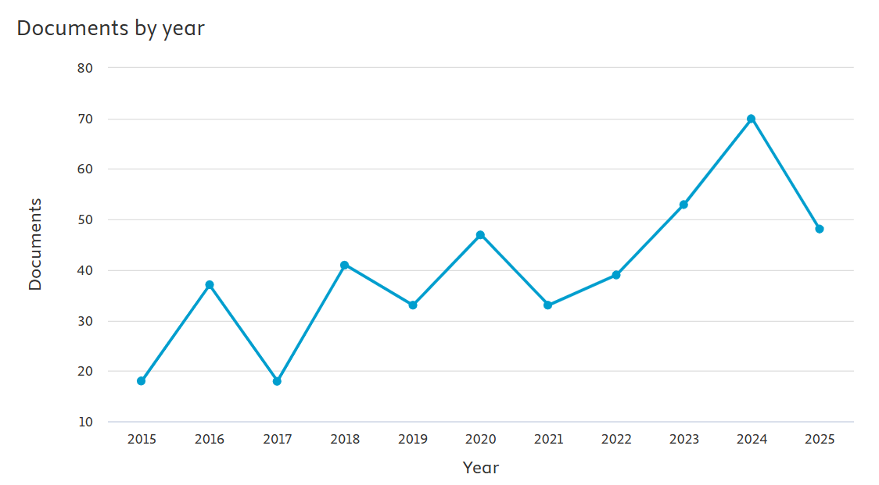
Source: analysis of results, extracted from the Scopus database

Figure 1. Document by year
The figure below illustrates the distribution of documents by type.
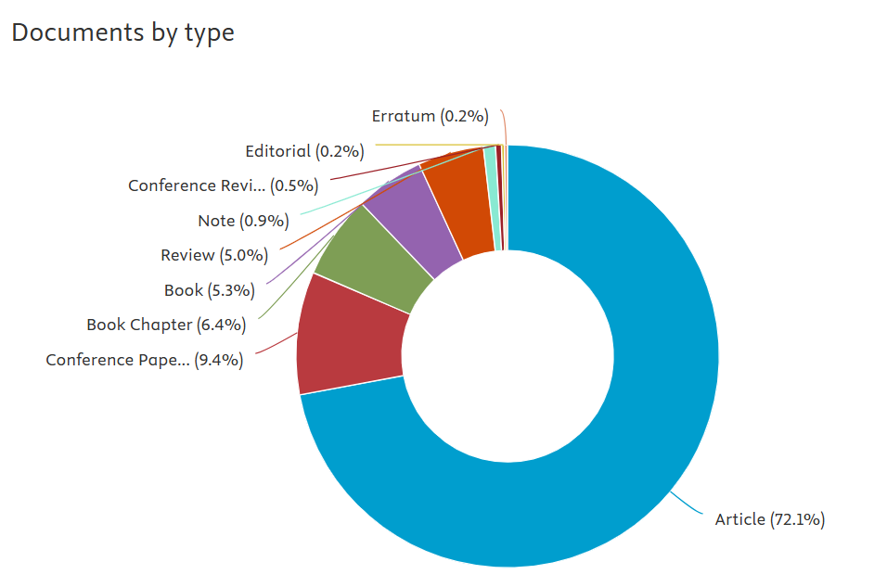
Source: analysis of results, extracted from the Scopus database
Figure 2. Document by type
An analysis of the types of documents published on academic libraries and sustainable development reveals a predominance of scientific articles, which account for 72.1% of all publications and constitute 315 articles.
This graph shows the geographical distribution of publications by country.
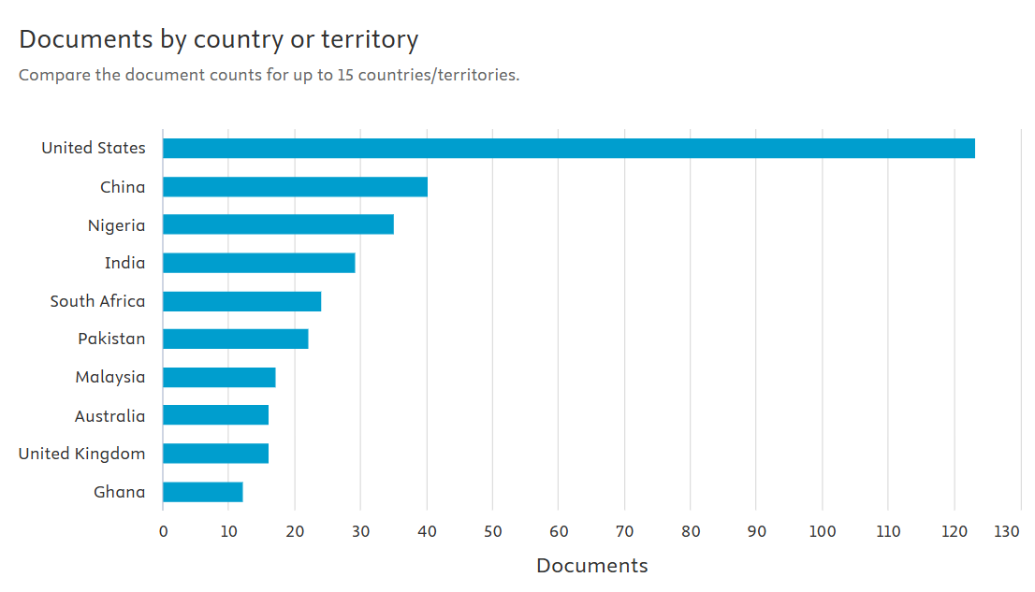
Source: analysis of results, extracted from the Scopus database
Figure 3. Geographical distribution of publications by country
The geographical distribution of publications reveals the dominance of the United States, which accounts for 123 documents, or nearly one-third of scientific output on the topic of university libraries and sustainable development. China follows with 40 documents, Nigeria with 35, and India with 29.
Similarly, here is a map showing geographical collaboration between authors:

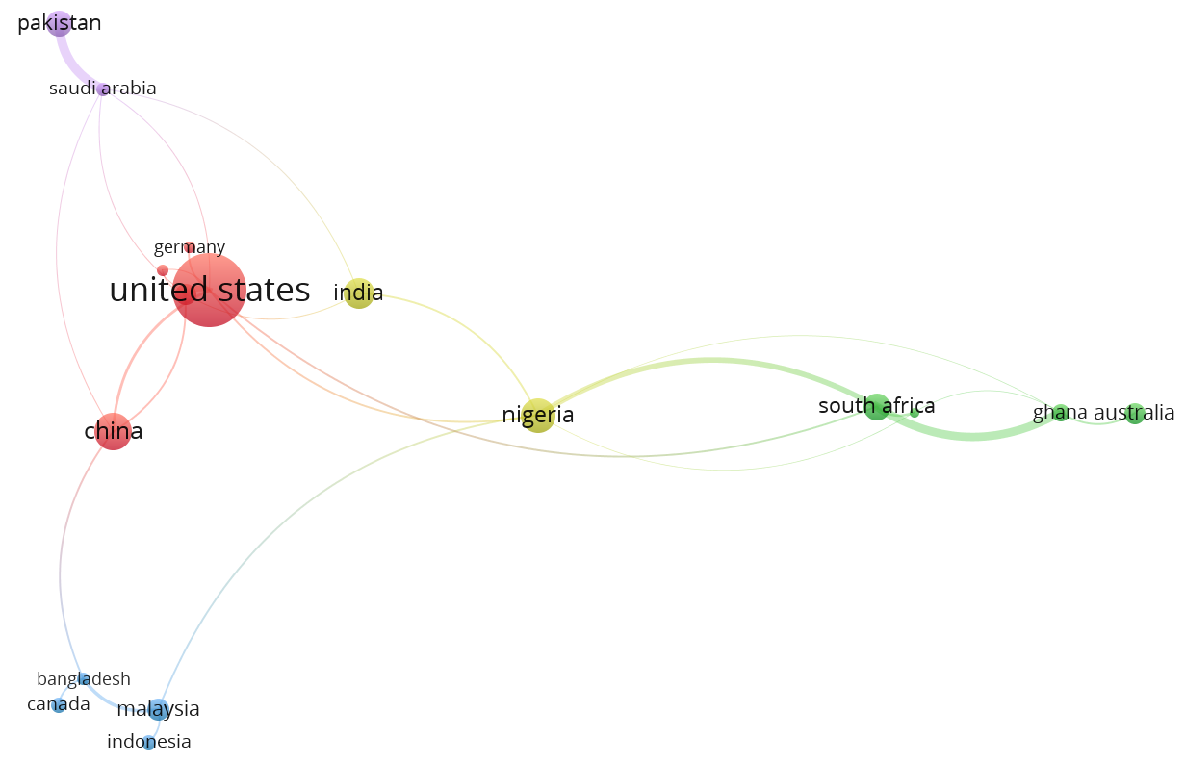
Figure 4. Geographical distribution of publications by country
Network visualization of international research collaborations. Node size represents scientific output, with larger nodes indicating higher productivity. Colors distinguish different collaboration clusters. Connection lines show collaborative relationships between countries, with line thickness proportional to the strength of collaboration.

This map of co-authors by country reveals the collaboration between authors by geographical area on a global scale. It includes 17 countries divided into four distinct clusters, with a total of 27 links. The visualization shows the position of the United States, which has the greatest weight (circle size), with a high volume of international collaborations, particularly with China, Germany, Nigeria, India, and Saudi Arabia. This confirms its dominance in scientific production in the field, functioning as a hub center for international collaboration. This centrality is accompanied by a network of partnerships with the red cluster, which includes the United States, China, the United Kingdom, and Germany.
The yellow and green cluster includes countries such as Nigeria, South Africa, Ghana, and Australia. The blue cluster is composed of Canada, Bangladesh, Indonesia, and Malaysia. The veiled cluster mainly connects Saudi Arabia and Pakistan. Inter-cluster links are also observed, particularly between Nigeria and the countries of the blue cluster.
This geographical collaboration implies collaboration between co-authors, as shown in the map below.
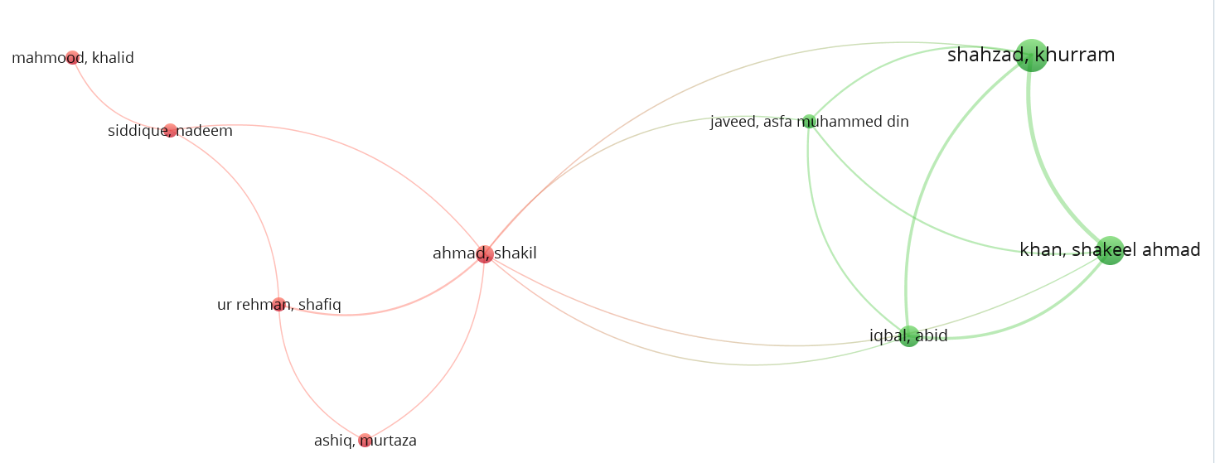
Figure 5 Co-autorship

The size of the nodes represents each author's research productivity, with larger nodes indicating a higher number of publications. The colors distinguish the different collaboration clusters: red cluster (Ahmad, Shakil, and collaborators) and green cluster (Shahzad, Khurram, and collaborators). The connecting lines illustrate the co-authorship relationships between researchers.

The co-author map shows a total of 9 authors, divided into 2 distinct clusters. There are 16 collaborations links. The links between authors vary in thickness, indicating different levels of collaboration between peers.
In the map above, the frequency and distribution of keywords were examined to better understand current research interests and priorities in this field.
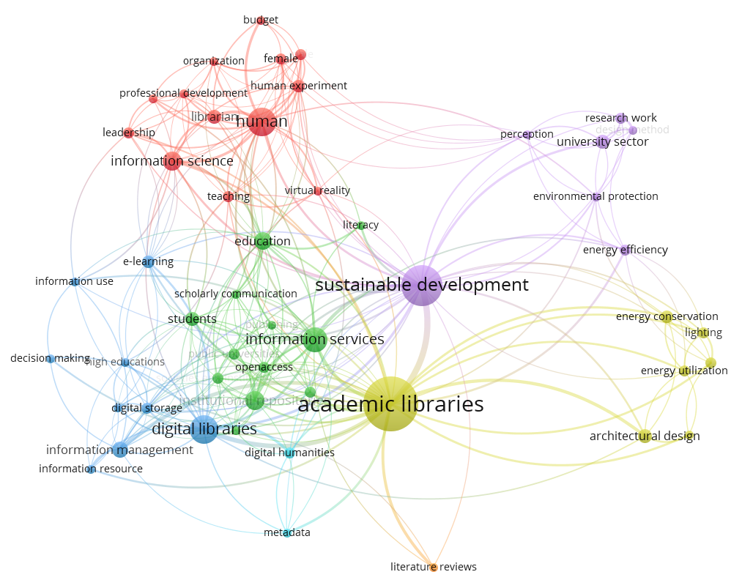
Figure 6 Keyword co-occurrence map
The size of the nodes represents the frequency of the keywords, the colors distinguish the thematic clusters. The connections indicate co-occurrence relationships between concepts

The spatial arrangement of nodes follows a semantic proximity model where the distance between keywords reflects the degree of conceptual association. Also, the distribution of links in this thematic network map shows high density in the central area of the network, gradually decreasing towards the peripheral regions. In addition, each thematic grouping is classified by a specific color to facilitate visual identification.
Co-occurrence analysis reveals a conceptual architecture of seven thematic clusters that can be divided into two main poles:
- The first cluster is information infrastructure, which focuses on “academic libraries” (yellow, with 36 links), “digital libraries” (blue, with 25 links), and “information services” (green, with 23 links). This pole is linked to “architectural design,” “energy conservation,” “energy utilization,” “lighting,” “natural lighting,” and “energy efficiency.”
- The second cluster is sustainable development (purple with 39 links), which revolves around “sustainable development,” “university sector,” and “research work.”
These two clusters are interconnected and are distributed with four other secondary thematic clusters, namely “Education” (green, 23 links), ‘Information’ (red, 16 links) and “Human” (red, 21 links). These clusters are connected by 151 links. All clusters are connected by 151 links.
The map below illustrates the temporal overlay of keyword co-occurrence, highlighting how research have evolved over time and revealing shifts in focus across different periods.

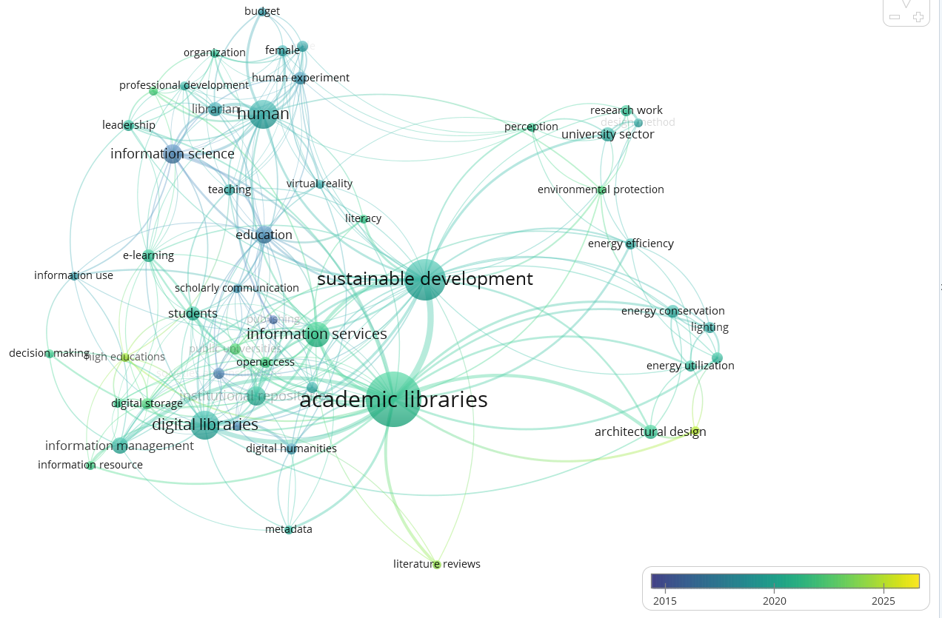

Figure 7 Temporal Overlay of Keywords Co-occurrence
The size of the nodes indicates the frequency of the terms, the colors represent the time period (blue=older, yellow=more recent). The connections show the relationships between concepts.
This temporal verlay map reveals the conceptual evolution of the field linking academic libraries and sustainable development between 2015 and 2025, with 51 items organized into 7 clusters linked by 299 connections. The temporal legend uses colors to indicate the chronology of the emergence of concepts. The concepts in green and yellow correspond to scientific output from 2020 to 2025; these concepts are “sustainable development,” “academic libraries,” “digital library,” “education,” and “human.” The central nodes “academic libraries” and “sustainable development” appear in green and yellow, indicating their conceptual centrality and relevance.

This figure illustrates the distribution of citations across various scientific journals:
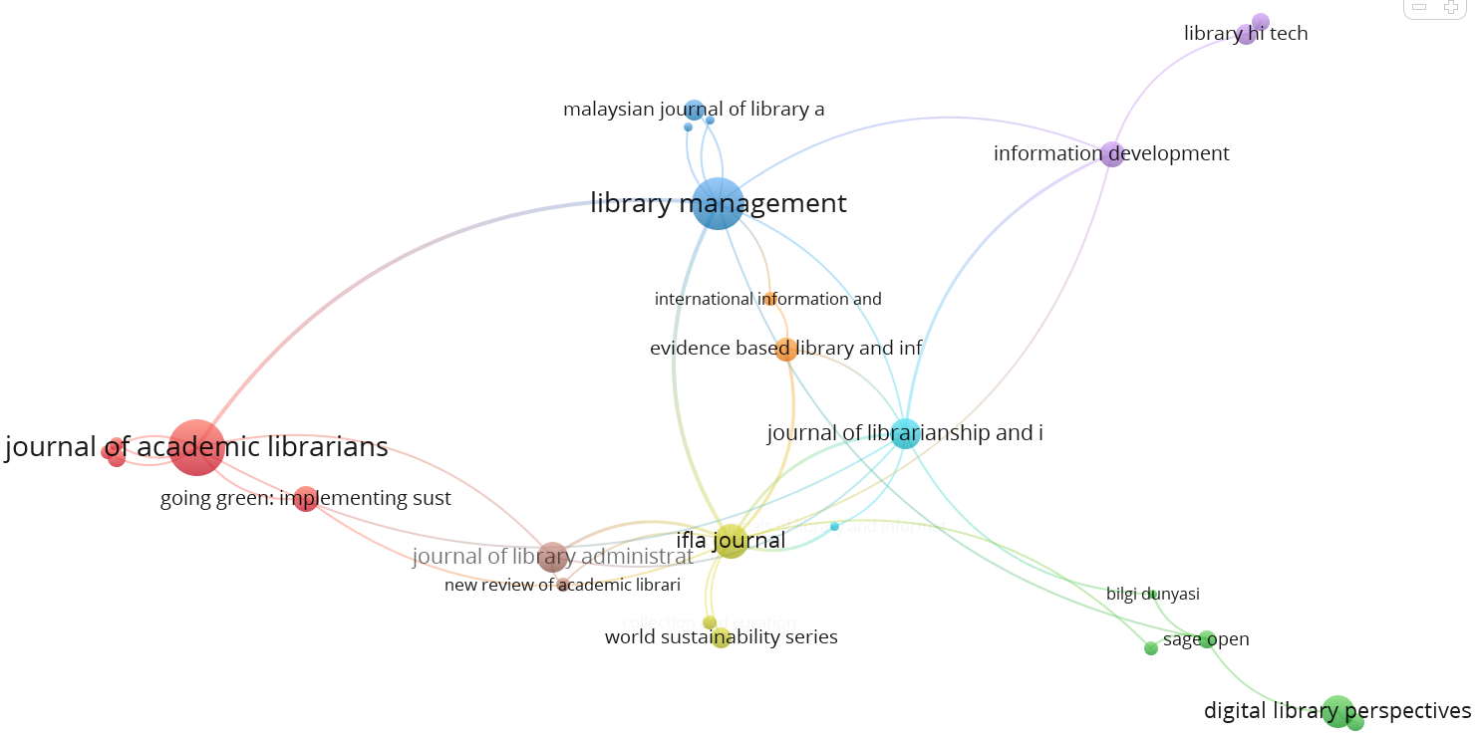
Figure 8 Citations by scientific journals
The size of the nodes represents the number of publications per journal, while the colors distinguish the thematic clusters.

This VOSviewer map shows a co-citation network of 26 journals organized into 8 distinct clusters, linked by 38 connections. The Journal of Academic Librarians occupies a central position with the largest node size, indicating its strong influence in the field. The clusters are spatially divided into thematic subgroups: professional publications (red cluster dominated by the Journal of Academic Librarians), management journals (blue cluster with Library Management), technology publications (green cluster with Digital Library Perspectives), and international organization journals (yellow cluster including IFLA Journal).
- Discussion
The results of our bibliometric analysis reveal that scientific research on university libraries and sustainable development is growing over the period from 2015 to 2025, with a notable acceleration after 2020. The results of a literature review conducted using the Web of Science database (Sahu, A., & Shivarama, J. 2025) confirm this significant increase in publications on sustainable development in relation to libraries in higher education institutions. This growth reflects environmental concerns and an increase in institutional commitment to sustainability. It also shows that university libraries are becoming increasingly involved in promoting and implementing the United Nations' sustainable development goals. Furthermore, the dominance of articles as a type of publication reflects the strong academic roots of this subject.
Furthermore, the ranking of scientific publications by country reveals a global dynamic driven by both powerful academic institutions and emerging countries. The United States, China, and India occupy central positions. The leadership of the United States reflects an active academic ecosystem structured around sustainable development. China's position as the second major hub in the geographical distribution, with specific connections to Southeast Asia (Malaysia), illustrates the emergence of an autonomous Sino-Asian collaboration hub.
The results of our study are consistent with those of Sahu and Shivarama (2025), which show significant growth in publications linking university libraries to sustainable development. Their bibliometric analysis, based on the Web of Science, reveals that the United States and China are among the main contributors.
The African continent, represented mainly by South Africa and Nigeria, occupies a peripheral position. However, their presence, along with that of Pakistan, reflects a mobilization of research in areas facing sustainable development challenges. On the other hand, European countries such as the United Kingdom appear to be lagging behind, on a par with Australia and Malaysia.
It should be noted that the Scopus database does not include all scientific research on this topic. Thus, this geographical marginalization calls into question the representativeness of the scientific corpus studied.
Analysis of the connections between India, Nigeria, and South Africa reveals a promising trend toward stronger partnerships. These countries seem to be actively engaged in areas such as education and sustainable development. This highlights the need for a collaborative approach to address global challenges such as climate change and inequality.
The results of our analysis are consistent with those of Sahu and Shivarama (2025), which show that research on sustainability in relation to university libraries is based on an international dynamic marked by collaboration between countries. Their study reveals the existence of structured co-publication networks involving more than 48 countries over the period 2014–2024. The United States, China, and Pakistan appear to be major hubs in terms of productivity and citations.
Furthermore, bibliometric analysis by keyword co-occurrence places the term “sustainable development” in a nodal position, revealing a gradual convergence between the traditional functions of university libraries and their contribution to sustainable development goals. Thus, this mapping highlights the emergence of a field of action in which university libraries no longer merely provide access to information, but become institutional actors committed to promoting the SDGs through eco-responsible practices and services.
Keyword analysis and the use of the VOSviewer tool highlight emerging trends and co-occurrences, providing an in-depth understanding of the structure and interrelationships within the field of research.
On the other hand, temporal visualization reveals that this fiel dis becomming more and more active and also an acceleration in the integration of sustainability concepts into university library research after 2020. The recent emergence of the terms “digital library” and “sustainable development” confirms the growing environmental awareness in the sector, as shown by the connections with concepts such as ‘human’ and “digital literacy,” which reveal an active commitment to society. This temporal evolution validates the hypothesis of a research field characterized by change and topicality, where academic libraries are redefining their role to integrate contemporary sustainability challenges.
The analysis of the map of scientific journals publishing in this field reveals relationships between different publications in the field of library management. The central positioning of the Journal of Academic Librarians indicates its predominant role as an influential source of knowledge, attracting numerous citations and establishing key references for the field. Connections with journals such as Library Management and International Information and Library Review highlight the diversity of perspectives in the literature. These journals address a variety of topics, ranging from management practices to technological innovations, reflecting a dynamic and evolving landscape.
The emergence of topics related to sustainability and community engagement in certain journals, as shown by the connection with “Going Green” and other initiatives, highlights a growing concern for responsible practices in the sector. This suggests that researchers and librarians are increasingly seeking to align their work with societal and environmental issues.
In addition, the presence of technology-focused journals, such as “Library Tech” and “Digital Library Perspectives,” indicates that technological innovation is at the heart of contemporary discussions. This reflects a necessary adaptation to digital developments and user expectations.
The results of this study align with the work of Dabengwa (2025), who highlights the growing commitment of university libraries to implementing the Sustainable Development Goals, while pointing out the limitations associated with documenting and evaluating these initiatives. Similarly, our findings confirm the existence of significant actions, but also reveal a lack of documentation that reduces their visibility and complicates their promotion.
Furthermore, the findings of Khalid et al. (2020) support our observations by highlighting the challenges in measuring the concrete impact of university libraries on the SDGs. However, while Khalid et al. emphasize the lack of reliable indicators, our analysis highlights the need to strengthen institutional mechanisms that more closely align library initiatives with cultural and educational policies. This complementarity between findings consolidates the validity of our recommendations and confirms that the integration of academic libraries into the dynamics of sustainable development remains a global and shared challenge.
This discussion validates the idea that university libraries are actors that can develop sustainable practices and services and raise awareness among students, professors, and other users about sustainable development.
After interpreting the conceptual clusters, dynamics of distribution and collaboration, emerging themes and scientific journal publishing through VOSviewer maps, it is essential to focus on the contributions of university libraries to the Sustainable Development Goals.
“ the sustainable library takes seriously and responds to the various economic, environmental and social challenges our societies confront. Sustainable libraries should act responsively and promote responsibility in their community in every possible way, not just by sharing reliable information. ” (Hauke et al., 2018, p.8)
Christopher Landes' study on university libraries at Freie Universität Berlin in Germany confirms that research on green libraries and environmental sustainability has grown considerably over the past fifteen years. However, two important observations emerge: on the one hand, the United States largely dominates this field of research, while Germany has relatively few publications on the concept of green libraries. On the other hand, the existing literature focuses mainly on descriptions of exemplary cases or model libraries, with little methodological reflection and theoretical approaches. (Hauke et al., 2018) adds that German university libraries already apply sustainable measures such as eco-friendly construction and energy efficiency, but without an explicit strategy or public communication.
Libraries are adopting “green” practices. The “green library” movement has been growing since the 1990s, particularly under the impetus of the American Library Association's Task Force on the Environment. (Jankowska & Marcum, n.d.). The concept of a “green library” extends beyond eco-friendly buildings to include services, collections, and educational and cultural activities focused on sustainability. It is a comprehensive approach, integrated at all levels of management.
Indeed, as a hub for education and culture as well as a technological mediator, academic libraries contribute to the achievement of several SDGs. They play a fundamental role in promoting quality education accessible to all, which is in line with SDG No. 4. They offer free access to a variety of educational resources, enabling lifelong learning.
At the same time, university libraries contribute to reducing inequalities and promoting social inclusion, in line with SDG No. 10. They democratize access to information and resources.
Academic libraries are not limited to education and democratization; they also play a crucial role in the sustainability of cities by creating open spaces for dialogue, creativity, and socialization, in line with SDG No. 11. In addition, academic library practices in resource management and environmental and climate initiatives are aligned with SDGs 12 and 13, which call for concrete action, sustainable consumption and production patterns, and action to combat climate change.
Furthermore, they are spaces for debate and discussion that promote the construction of a transparent society. They contribute to SDG No. 16 by providing a framework for democracy and civic engagement.
Finally, academic libraries are committed to creating sustainable partnerships between institutions, researchers, and communities, contributing to SDG No. 17 in order to strengthen and broaden the scope of their actions in promoting sustainable development.
Around the world, several university libraries are striving to align themselves with the SDGs. Sustainable architecture promotes a responsible learning environment, as illustrated by the Merced Library in California. This library, originally designed to fit into a “green” campus, adopts an open and collaborative design that encourages active learning and the co-construction of knowledge. In addition to reducing its environmental impact, it promotes social and educational sustainability. This library operates according to social, economic, and ecological principles. This strategy directly supports SDG 4 (quality education) by promoting an environment conducive to equitable learning, SDG 11 (sustainable cities and communities) by incorporating eco-responsible urban planning, and SDG 12 (responsible consumption and production) by making sustainable design and management decisions (Li, 2017). According to Afacan (2017), the design of environmentally friendly buildings that take into account standards such as energy efficiency, indoor air quality, and equitable access is another aspect of university library sustainability.
Another example is the library at the Chinese University of Hong Kong, which has incorporated sustainability as a strategic focus into its management policy since 2013. This university library promotes electronic formats in its collection development to help address the constraints of Hong Kong's tropical climate by eliminating the need for intensive air conditioning for paper conservation and sharing resources with seven other university libraries.
Its infrastructure demonstrates sustainability through the creation of an organic garden and a 6,100-square-meter BEAM Platinum-certified extension, featuring a green roof, low-emissivity double glazing, automated environmental sensors, and optimized natural lighting. Quantified results include an 8% reduction in electricity consumption, 32% savings on air conditioning, and 12,792 kg of recycled paper, avoiding 61,508 kg of CO2 emissions. (Hauke et al., 2018)
Another example is the academic libraries of United States International University-Africa USIU-A in Kenya, which were inspired by international references such as the Warsaw Library with its rooftop botanical garden and the Chinese Liyuan Library, which uses wooden sticks to diffuse natural light (Hauke et al., 2018) and are aligning themselves with global IFLA trends to transform their spaces into sustainable environments.
Its building covers an area of 10,000 square meters and incorporates energy efficiency features as well as a 20-square-meter central organic garden called “Mama Africa,” which generates a “chimney effect” via the atrium for automated natural ventilation. Thanks to this architecture, the USIU-A library won the national Maktaba award.
The layout of these spaces meets the needs of different generations. In fact, 70% of young people prefer collaborative areas, while 30% opt for quiet workspaces. The latter are designed with minimal lighting of 50 lux and a light uniformity of 0.3. In addition, the use of solar double glazing and the integration of vegetation help reduce stress by 40%, according to behavioral studies. Thus, these spaces are transformed into true social “third places,” promoting interaction and conviviality. (Hauke et al., 2018)
A structured and sustained professional development approach can also promote the sustainable professional development of academic librarians, as evidenced by the professional development program at a Tier One research university library in the southwestern United States. This program, managed by the Career Development Committee, has been in continuous operation for eight years. Its goal is to support academic librarians in their activities. (O'Toole et al., 2023). Thus, sustainable development must be integrated into the initial and continuing training of librarians.
Furthermore, social inclusion is also part of the practices that a sustainable academic library can adopt. The best example of this is the large Henry Madden Library, located in the heart of the Fresno State campus (California State University, Fresno), which in 2014 launched a personalized, flexible, and collaborative sustainable library orientation and training program specifically designed for international students, targeting mainly new arrivals each semester. (Langer & Kubo, 2015)
The author Pionke (2016) recommends several actions to improve accessibility in university libraries. He emphasizes the need to design spaces and services that can be used by everyone, stating that “incorporating accessibility from the beginning will ensure that all people can use the library.”(Pionke, 2016, p. 322). He adds that people with disabilities must be involved in the design process. The author stresses the importance of this approach, saying, “keeping accessibility in mind, including incorporating the voices and narratives of people who are different from ourselves.” (Pionke, 2016, p. 320). In addition, all staff should be trained on accessibility issues. This will help create a culture of empathy. According to the author, accessibility is a matter of social justice.
Philip Ephraim developed the idea that “green management” should be understood as a holistic task, integrated into all library management processes. This approach involves the use of environmentally friendly and renewable raw materials, regenerative energies, the purchase of environmentally sustainable products, and the recycling of consumer goods. (Hauke et al., 2018)
In order to ensure green management, tools and indicators need to be developed to measure water, energy, and paper consumption, the amount of waste generated, and the ecological footprint of digital activities. (Jankowska & Marcum, n.d.)
Similarly, McCord et al. (2025) propose an environmental audit tool for publishers by evaluating the practices of academic publishers and the sustainability goals of academic libraries. In addition, by studying 39 Australian libraries, Roxanne Missingham explores the evolution of academic library evaluation methods, proposing an approach based on the united nations Sustainable Development Goals . (Missingham, 2021)
Furthermore, librarians are called upon to include the acquisition of books on sustainability and eco-responsibility in their collection development policy, as well as to strengthen digital infrastructure. They must also create and host events and workshops on linguistic and cultural inclusion and ecological transition (repair, recycling, urban agriculture, etc.). Cultural activities make the university library a sustainable place. In addition, librarians must ensure that they develop cooperation networks and encourage the sharing of practices and collaboration between academic libraries committed to sustainability.
It should be noted that the above-mentioned initiatives are only a representative sample, taken from the literature, of a broader global movement. Indeed, many other university libraries across four continents are actively working to integrate the Sustainable Development Goals into their strategies and practices.Examples include the King Abdullah University of Science & Technology Library in Saudi Arabia, the Punjab University Library in Pakistan, the University of Malaya Library in Malaysia, the Istinye University Library in Turkey, The Sir Duncan Rice Library in Aberdeen in the United Kingdom, the University of Southern Denmark Library in Denmark, the Biblioteca Universitaria de Sevilla in Spain, and the libraries of the University of Franche-Comté in France.
Finally, we highlight the existence of a practical reference guide (Jankowska, 2014) for all academic libraries that wish to contribute to the promotion of sustainable development. It shows how to integrate this dimension into each of their missions : training students in information literacy, enriching collections, supporting scientific research, and involvement in cultural life. This toolkit presents inspiring case studies and activities that librarians can apply. It also offers academic libraries the tools not only to become more than places of knowledge, but also to transform themselves into committed and influential actors, capable of bringing together sustainable projects, creating synergies, and actively contributing to ecological and social transition within universities. In addition to this toolkit, there is also the IFLA Guidelines for Green and Sustainable Libraries.

- Conclusion
This study highlights the growing and multifunctional role of university libraries in promoting sustainable development goals. Through a combination of bibliometric analysis and literature review, it reveals libraries are moving beyond their traditional function of providing access to information. They will become actors in the fields of environmental sustainability and social inclusion.
However, several challenges remain: the lack of reliable indicators to measure the concrete impact of libraries on the SDGs. Also, the under-integration of university library initiatives into cultural and educational policies. Furthermore, institutional and structural constraints limit their scope of action.
Based on these findings, this study offers recommendations to university administrators and librarians. First, institutional integration mechanisms should be strengthened and translated into action plans. Second, reliable indicators should also be developed to systematically measure the impact of libraries on the SDGs. In addition, librarians should be trained and mobilized, innovation and sustainability should be encouraged among librarians, and eco-responsible practices should be promoted in the management of buildings, collections, and services. Finally, collaboration should be fostered and inter-university and international partnership networks should be established in order to share practices and strengthen the overall impact of any initiative.
Our conclusions confirm that integrating university libraries into the sustainable development process requires appropriate assessment tools, strong institutional recognition and integration, and enhanced cooperation among stakeholders.

References

- Afacan, Y. (2017). Sustainable library buildings: Green design needs and interior architecture students’ ideas for special collection rooms. The Journal of Academic Librarianship, 43(4), 375–383. https://doi.org/10.1016/j.acalib.2017.07.002
- Atta-Obeng, L., & Dadzie, P. S. (2020). Promoting Sustainable Development Goal 4: The role of academic libraries in Ghana. International Information & Library Review, 52(3), 177-192. https://doi.org/10.1080/10572317.2019.1675445
- Dabengwa, I. (2025). Mapping the academic library contributions to sustainable development goals: A mixed-methods literature review. Evidence Based Library and Information Practice, https://doi.org/10.18438/eblip30982
- Dei, D.-G. J., & Asante, F. Y. (2022). Role of academic libraries in the achievement of quality education as a sustainable development goal. Library Management, 43(6/7), 439-459. https://doi.org/10.1108/LM-02-2022-0013
- Gauthier, É. (1998). L’analyse bibliométrique de la recherche scientifique et technologique : Guide méthodologique d’utilisation et d’interprétation (No 8, Projet de remaniement des sciences et de la technologie ; produit no 88F0006XPB au catalogue). Observatoire des sciences et des technologies (CIRST) ; Statistique Canada.
- Hauke, P., Charney, M., & Sahavirta, H. (2018). Going green: Implementing sustainable strategies in libraries around the world buildings, management, programmes and services. Walter de Gruyter GmbH.
- Jacquemot, P. (2017). Le dictionnaire encyclopédique du développement durable (720 p.). Paris : Sciences humaines éditions.
- Jacquinot-Delaunay, G., & Fichez, E. (2008). L’Université et les TIC : Chronique d’une innovation annoncée. De Boeck Université.
- Jankowska, M. A. (Ed.). (2014). Focus on educating for sustainability: Toolkit for academic libraries. Library Juice Press.
- Jankowska, M. A., & Marcum, J. W. (2010). Sustainability challenge for academic libraries: Planning for the future.
- Khalid, A., Malik, G. F., & Mahmood, K. (2021). Sustainable development challenges in libraries: A systematic literature review (2000–2020). The Journal of Academic Librarianship. https://doi.org/10.1016/j.acalib.2021.102347
- Langer, C., & Kubo, H. (2015). From the ground up: Creating a sustainable library outreach program for international students. Journal of Library Administration. https://doi.org/10.1080/01930826.2015.1085232
- Leal Filho, W., Wu, Y.-C. J., Brandli, L. L., Avila, L. V., Azeiteiro, U. M., Caeiro, S., & Madruga, L. R. D. R. G. (2017). Identifying and overcoming obstacles to the implementation of sustainable development at universities. Journal of Integrative Environmental Sciences. https://doi.org/10.1080/1943815X.2017.1362007
- Li, H. (2017). Built to succeed: Sustainable learning environment at UC Merced Library. Library Management, 38(2–3), 175–180. https://doi.org/10.1108/LM-01-2017-0003
- McCord, D., Cassady, S., Roman, P., Cato, J., & Mantz, E. (2025). Sustainability in library collection development: Introducing a green audit template. Canadian Journal of Academic Librarianship, 11. https://doi.org/10.33137/cjal-rcbu.v11.43852
- Missingham, R. (2021). A new lens for evaluation – Assessing academic libraries using the UN Sustainable Development Goals. Journal of Library Administration, 61(3), 386-401. https://doi.org/10.1080/01930826.2021.1883376
- Myntti, J., & Zoom, J. (Eds.). (2019). Digital preservation in libraries: Preparing for a sustainable future. ALA Editions.
- O’Toole, E., Sassen, C., Willis, S., Guerrero, S., & Berg, J. (2023). Creating a sustainable professional development program. Journal of Library Administration. https://doi.org/10.1080/01930826.2022.2146438
- Phillips, A. (2016). Educating at scale: Sustainable library learning at the University of Melbourne. Library Management. https://doi.org/10.1108/lm-04-2016-0020
- Pionke, J. J. (2016). Sustainable library services for all. Library Management. https://doi.org/10.1108/lm-04-2016-0030
- Sahu, A., & Shivarama, J. (2025). Sustainable Development Goals with libraries in higher education: Comprehensive bibliometrics analysis with the altmetric score comparison. Information Discovery and Delivery. https://doi.org/10.1108/IDD-10-2024-0163
- Smyrnova-Trybulska, E., Morze, N., & Kuzminska, O. (2018). Mapping and visualization of a research network: Case study. Edukacja – Technika – Informatyka, 23(1), 327-332. https://doi.org/10.15584/eti.2018.1.44
- Stephens, J. C., Hernandez, M. E., Román, M., Graham, A. C., & Scholz, R. W. (2008). Higher education as a change agent for sustainability in different cultures and contexts. International Journal of Sustainability in Higher Education. https://doi.org/10.1108/14676370810885916
- Sustainable library services built on open source software: A case story from Kenya. (2008). In U. Knutsen & T. A. Dahl, Managing technologies and automated library systems in developing countries: Open source vs commercial options (pp. 52-60). Walter de Gruyter – K. G. Saur. https://doi.org/10.1515/9783598440953.2.52
- Sustaining library staff of the future: Emerging requirements. (2015). In U. I. Mbofung, Advances in library administration and organization (pp. 277-312). Emerald Group Publishing Limited. https://doi.org/10.1108/s0732-067120150000034023
- Vargas-Quesada, B., & Moya Anegón, F. de. (2007). Visualizing the structure of science. Springer Berlin Heidelberg. https://doi.org/10.1007/3-540-69728-4

