Title of Full Paper
(Author Guidelines for ICRU 2025 Conference)
First AUTHOR^{1,*,}, Second AUTHOR² and Third AUTHOR¹
¹College of City and Regional Planning, University of Duhok, Country Name - E-mail: aaa@uod.ac
²College of Engineering, University of Knowledge, Country Name - E-mail: bbb@kn.edu.ac
* Corresponding author: College of City and Regional Planning, University of Duhok, Kurdistan Region, Iraq. Tel: +964790153xxxx.
Abstract
We thank you for your participation in 4th 2025 ICRU_SDGS and look forward to meeting you in Duhok on September 22-23, 2025. These instructions give you the basic guidelines for preparing a full paper for the 4th 2025 ICRU_SDGS conference proceedings. Authors are invited to submit electronically a manuscript (not exceeding 10000 words) via the online facility available on the conference website.
submitted papers will undergo a peer-review process. Accepted manuscripts will be included in the conference proceedings. In addition, selected papers may be considered for publication in affiliated journals, pending the authors’ consent. Upon approval, authors must adhere to the respective journal's submission guidelines and publication policies.

Keywords: (Up to 5 keywords) Keywords; Keywords should be separated by a semi-colon

- Introduction
We ask that authors make their papers look exactly like this document. The easiest way to do this is simply to download a template from the conference website and replace the content with your own material. Papers should clearly describe the background of the subject, the author’s work, including the methods used, and a concluding discussion on the importance of the work.
  - Page Size, Page Numbering, Headers, and Footers
The paper should be valuable and should not have been published or submitted for publication in any other Journals. The text should be complete with an abstract, introduction, material and methods, results, discussion, and reference. The text must not exceed 10000 words..
    - Page Size
The paper size should be A4 size and page margins must be 2.5 cm on top and bottom, 3 cm left, and 2 cm right. All material should be formatted and displayed in A4 paper size. “Left justify” all text, “single-spaced”. MS Word may try to change these dimensions in unexpected ways, so please double-check the formatting.
    - Page Numbering, Headers, and Footers
Do not include footers or page numbers in your submission. These will be added when the publications are assembled.
- Title
Your paper’s title should be capitalized in Times New Roman size-16;-bold; centered; Line Spacing: fixed-20pt; Paragraph Spacing.
- Authors and Affiliations
The full name(s) of the author(s) should be written only on the first page, capitalized, 8 pt, normal, centered, and spaced after 18 pt. For example, Nilson Robert Richard.
- Abstract and Keywords
Every submission should begin with an abstract of no more than 200 words, followed by a set of keywords. The abstract should be a concise statement of the problem, approach, and conclusions of the work described. The abstract body should be 8 pt., bold, aligned left, and single-spaced. Up to 5 keywords must be provided at the end of the abstract. The keywords title must be capitalized, 8 pt., aligned left, and Italic. The keywords should be written in 8 pt., Italic, and their initials should be capitalized. It must not contain bibliographical references or references to figures. Avoid abbreviations in abstracts.
- Typeset Text (body text)
The content text must be Normal, 10 pt., Times New Roman, exactly 12 lines spaced, and justified. Each paragraph should be spaced after 6 pt. The first line of the paragraphs should NOT be indented.
- Equations
The equations should be centered, 6 pt space above and below the text. Equations should be numbered sequentially in the right-hand side and in parenthesis. They should be referred to in the text as ‘Equation (1)’. Microsoft Equation Editor should be used to edit equations. Below is an example created with Microsoft Equation 3.0.
(1)
(2)
(3)
- Tables
Tables should be placed close to the first reference to them in the text and numbered consecutively. Table headings should be above the tables. All Table outline borders should be (1 ½ pt.), inside border should be (½ pt.); table details should be in Arial font and written with 7 pt. the figure and table names must be written in Arial font, 8 pt size. The title must be written in the middle on top with a space 4 pt after. The following is the example for Table 1. The term “Table” must be bold.
Table 1. Title of example table
 | Column 1 and Column 2 |  | Column 3 | Column 4
Row 1
Row 2
Row 3*
Row 4
Row 5
* Inset your note (if any)
- Figures
All figures and photographs should be with good contrast and resolution and they should be numbered consecutively. Figures not cited in the text should not be presented. Figure captions should be centered below the figures with Arial (8 pt size) font. Leave 4 pt space before and 12 pt after the figure caption. If the Figure and Table names have to be more than one line, the line spacing should be single-spaced, and the term “Figure” must be bold.
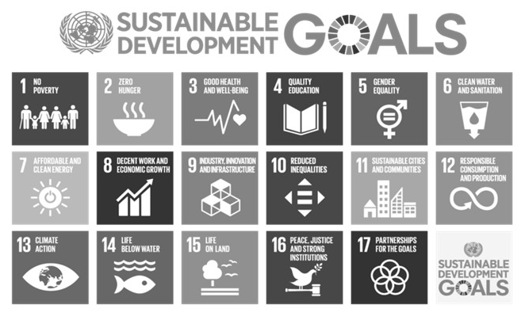
Figure 1. Title of example Figure
- Notes, Symbols, and Units
Please avoid using footnotes and the required information should be inserted directly in the text. However, for tables, the following reference marks should be used: *, **, etc. and the actual footnotes set directly underneath the table. And, always use the official SI notations for units.
- List of References
In 2025 ICRU_SDGS 2023, we use a standard APA style for preparing the references list at the end of any article. All lines after the first line of each entry in your reference list should be indented one cm from the left margin (hanging indentation).
- Citation
For citation in the text cite a source by giving the author's name with the year of publication in parentheses, as detailed in the APA style. If several papers by the same author(s) and from the same year are cited, a, b, c, etc. should be put after the year of publication.
- Conclusions
Please use this MS Word template directly for the preparation of your manuscript. We thank you very much for your cooperation and look forward to welcoming you to Duhok City in September 2023.

Acknowledgments
Include any acknowledgments. No section number should be provided.

References
- Alesina, A., Giuliano, P., & Nunn, N. (2011). Fertility and the Plough. American Economic Review, 101(3), 499-503. http://dx.doi.org/10.1109/2.901164
- Smith, Joe, (1999), One of Volvo's core values. [Online] Available: http://www.volvo.com/environment/index.htm (July 7, 1999)
- Strunk, W., Jr., & White, E. B. (1979). The elements of style. (3rd ed.). New York: Macmillan, (Chapter 4).
- Van der Geer, J., Hanraads, J. A. J., & Lupton R. A. (2000). The art of writing a scientific article. Journal of Scientific Communications, 163, 51-59.

Note:
One of the options for display of authors’ ORCID iDs:
- the iD icon, hyperlinked to the iD URI:

